**Part2**

**1. 喜欢说话的人**

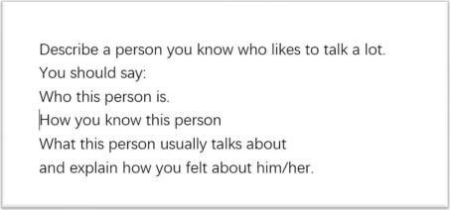

His name is CongMingXueZhang, which can be loosely translated as Mr. Smart. He is an

influencer on DouYin, the Chinese version of TikTok. He creates videos about his studying

methods and experience. He is a real talker.

How I knew him? Actually, I found out about him by accident. My friend was browsing videos

on DouYin the other day, and shared his videos with me. The video, I still remember, was

about how to memorize difficult vocabulary in English. It was so interesting, so intriguing, and

it captivated me at once, and I started following him since then.

Basically, he shares videos and talks a lot about his studying experiences, studying methods, and even life lessons, sometimes. From his video, you can totally tell that he is so talkative and smart, it’s like everything in studying is a piece of cake to him, he is almost, how to put it, omniscient, I guess. The most impressive video was how he managed to remember 1000 words in three days. I mean, come on, that’s more than difficult, it’s very difficult, it’s a daunting task. But, he did it! He was really voluble about how he divided these words into different groups, and how he adopted various ways to memorize them, and even how he took advantage of different locations to consolidate the memories. I was surprised to see this, no, I was more than surprised, I was stunned.

This is him, a superman in the academic field. I guess I followed him not only because he is

talkative and smart, but also because deep deep down, he resonates with me, I want to

become smart, become brilliant, and become omniscient as well. And I believe his videos are

going to go viral on DouYin very soon.

This is him, a superman in the academic field. I guess I followed him not only because he is

talkative and smart, but also because deep deep down, he resonates with me, I want to

become smart, become brilliant, and become omniscient as well. And I believe his videos are

going to go viral on DouYin very soon.

**主题词汇和亮眼表达：**

**talker：健谈的人**

**talkative：健谈的**

**voluble（/** ˈ**v**ɒ**lj**ə**b(**ə**)l）： 滔滔不绝的**

**2. 善于招待客人的人**

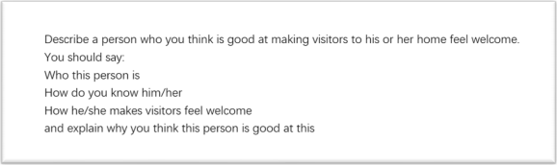

This reminds me of my English teacher at my university. He is a nice old man. He would throw

a party every week and invite me and other classmates to his house.

During the party, he would always share some knowledge about English studying. The first time I went to the party, I still remember, he talked about how to memorize difficult vocabulary

in English. It was so interesting, so intriguing, and it captivated me at once, and I started to

go to his party a lot since then.

Basically, he shares knowledge about his studying experiences, studying methods, and even life lessons, sometimes. From his talk, you can totally tell that he is so knowledgeable, it’s like everything in studying is a piece of cake to him, he is almost, how to put it, omniscient, I guess. More importantly, he doesn’t teach us in a condescending way, but in a friendly way, that makes us comfortable, relaxed, and feel at home. The most impressive part was how he managed to remember 1000 words in three days. I mean, come on, that’s more than difficult, it’s very difficult, it’s a daunting task. But, he did it! He shared how he divided these words into different groups, and how he adopted various ways to memorize them, and even how he took advantage of different locations to consolidate the memories. I was surprised to see

this, no, I was more than surprised, I was stunned.

This is him, a superman in the academic field. I guess I went to his party not only because of the great food and drinks, but also because deep deep down, he resonates with me, I want to become smart, become brilliant, and become omniscient as well.

**主题词汇和亮眼表达：**

**throw a party：办一个 party**

**condescending：高高在上的**

**3. 和老人的有趣谈话**

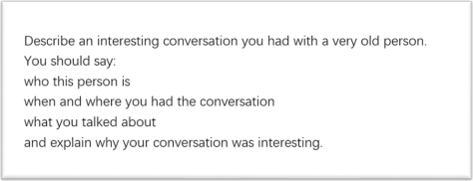

This reminds me of my English teacher at my university. He is a nice old man. He would throw

a party every week and invite me and other classmates to his house. And we had a lot of

interesting and enlightening conversations.

During the party, he would always share some knowledge about English studying. The first time I went to the party, I still remember, he talked about how to memorize difficult vocabulary

in English. It was so interesting, so intriguing, and it captivated me at once, and I started to

go to his party a lot since then, although I basically listened to him talking during the

conversation.

Basically, he would talk with me about studying experiences, studying methods, and even life lessons, sometimes. From our conversation, you can totally tell that he is so knowledgeable, it’s like everything in studying is a piece of cake to him, he is almost, how to put it, omniscient, I guess. More importantly, he would not dominate the conversation, but would listen to me as well. The most interesting conversation we ever had was how he managed to remember 1000 words in three days. I mean, come on, that’s more than difficult, it’s very difficult, it’s a daunting task. But, he did it! He shared how he divided these words into different groups,

and how he adopted various ways to memorize them, and even how he took advantage of

different locations to consolidate the memories. I was surprised to see this, no, I was more

than surprised, I was stunned.

This is him, a superman in the academic field. I guess I love to talk to him not only because

he is knowledgeable, but also because deep deep down, he resonates with me, I want to

become smart, become brilliant, and become omniscient as well.

**主题词汇和亮眼表达：**

**throw a party：办一个 party**

**enlightening：有启发性的**

**dominate the conversation：霸占谈话（的主导权）**

**4. 给力的队友**

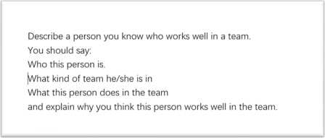

This reminds me of CongMingXueZhang, I teamed up with him last semester, and we gave a

presentation together. He was really cooperative and smart.

I knew about him because of his presentation. The presentation, I still remember, was about

how to memorize difficult vocabulary in English. It was so interesting, so intriguing, and it

captivated me at once, and I therefore asked him to work with him to give the final

presentation.

During the preparation stage, he shared knowledge about his studying experiences, studying methods, and even life lessons, sometimes. From his talk, you can totally tell that he is so knowledgeable, it’s like everything in studying is a piece of cake to him, he is almost, how to put it, omniscient, I guess. More importantly, he would also listen to me, and try to work with

my pace.

We finally gave a great presentation. The most impressive part was about how we managed

to remember 1000 words in three days. I mean, come on, that’s more than difficult, it’s very

difficult, it’s a daunting task. But, we did it! He shared how we divided these words into

different groups, and how we adopted various ways to memorize them, and I took his turn

and shared how we took advantage of different locations to consolidate the memories. At

last, all the students were surprised to see this, no, they were more than surprised, they were

stunned.

This is him, a superman in the academic field. I guess I like to work with him not only because he is smart, but also because deep deep down, he is modest and flexible, and listens to people’s opinion, that made it easy and enjoyable to work with him.

**主题词汇和亮眼表达：**

**team up with sb：和 XX 组队**

**cooperative：有合作精神的**

**stage：阶段**

**pace：节奏**

**flexible：懂变通的**

**地**

**5. 让人放松的地方**

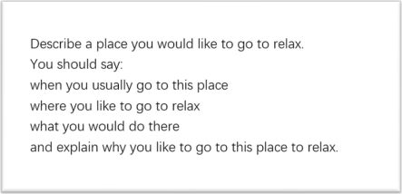

Well, I have always been very attached to the countryside. And I can totally relax when I am

there. My grandparents live there and I went there last summer. It is just so peaceful and quiet,

or you may say, it is tranquil. It slows everything down, and blocks out all the hustle and bustle

of the city.

I go to the countryside every summer. It is easier for me to feel the beauty of nature when I

am there. You can always find peace there. It’s not a cliché, I really feel so. I do. In the

countryside, you don’t need someone else to tell you spring is here. Instead, you get to see

the little buds and the sprouting flowers. I mean, you can see the change of seasons, and it’s

with your own eyes. Everything can be so natural, so real, and so tangible. It’s really relaxing.

Last summer, when I was in the countryside, I found something even more meaningful and

mentally relaxing: the bonds between people. I mean, people living in the city are always so

busy. They are always buzzing around, never willing to spare a second to say hi. You can feel

the distance between people. We are separated by endless traffic jams, by all the tall , fancy

but boring buildings. But when I was in the countryside, things were totally different. The

community there is small but close -knit. People know each other, care about each other, and sympathize with each other. It’s good to know there is always a friendly and relaxing place for

you.

**6. 带来好处的公共设施**

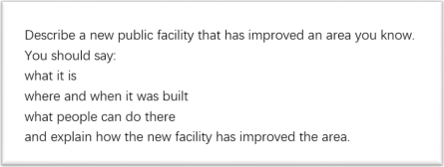

There is actually an amazing facility near my community. It’s a garden, a chatting garden, a

garden where people can sit down and chat.

The thing I hate about living in the city is that it’s far from nature. Well, I have always been very attached to the countryside. It is just so peaceful and quiet, or you may say, it is tranquil. It slows everything down and blocks out all the hustle and bustle of the city.

So I am very glad this new garden was built last year, with all the trees and various flowers, and I often go there by myself. Now it is easier for me to feel the beauty of nature when I am there. You can always find peace there. It’s not a cliché, I really feel so. I do. In the garden, you don’t need someone else to tell you spring is here. Instead, you get to see the little buds and the sprouting flowers. I mean, you can see the change of seasons, and it’s with your own eyes. Everything can be so natural, so real, and so tangible.

Another benefit of this garden is that it reinforces the bonds between people. I mean, people

living in the city are always so busy. They are always buzzing around, never willing to spare a

second to say hi. You can feel the distance between people. We are separated by endless

traffic jams, by all the tall, fancy but boring buildings. But now, things are totally different: with

the garden, people, including me, my parents, my grandparents, and all the neighbors can all

sit down and chat. The community is small but close-knit now. People know each other, care

about each other, and sympathize with each other. It’s good to know there is always a place

like this in the big city.

**主题词汇和亮眼表达：**

**community：社区**

**various：多样的**

**reinforces：加强**

**物**

**7. 离不开的物品**

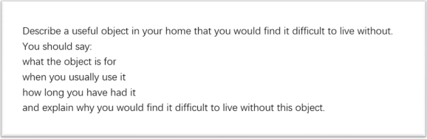

There is one photo on my desk, and there is a cake in the photo. The photo is emotionally indispensable/necessary for me. It was a handmade mousse cake, my girlfriend’s favorite flavor! Actually, I made the cake for our second anniversary. I spent the whole day making the cake, and she felt so excited, so happy, so, how to say, exhilarated to receive such a present. And this is when I took the photo, to commemorate the moment.

And I still remember the end of that day, we talked a lot, from the cake to other stuff. It seems

that there used to be a line, I mean, a boundary, between us, but because of the cake, the

boundary was gone. We became much closer, and that’s great. Every now and then, I would

watch the photo, and feel like I am the luckiest person in the world. I feel like I can’t live

without the photo.

When you think about friendship, or any other interpersonal relationships, it is always about loving and caring for each other. I mean, no one is an island. Sending a handmade gift is the best way to say: we are bonding. When someone receives something so kind, so personal, so genuine, they will be touched. That’s why the cake makes me happy, and the photo has

become part of my life: they represent the relationship between me and my girlfriend.

**主题词汇和亮眼表达：**

**indispensable：不可或缺的**

**commemorate：纪念**

**every now and then：时不时**

**represent：代表**

**8. 制服**

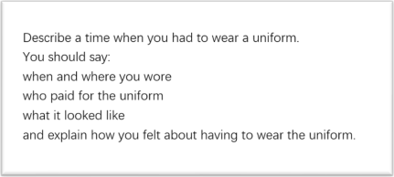

This reminds me of a uniform made by my best friend. I think it was last Halloween. My best friend was being mysterious all day. She told me she had a big surprise for me. We met at a nice little restaurant as planned. She carefully placed a beautiful box on the table. It was a box

with a lot of materials in it: white T-shirts, paper, scissors, and so on. She told me, she spent the whole day collecting the stuff, and she was going to make the Halloween uniform for me! I felt so excited, so happy, so, how to say, exhilarated to receive such a present.

She was not a professional handicraftsman. But this is a unique present. One of a kind! Think

about it, she had to search for the ways of making a uniform, collect all the materials, and all

the designing! After all, she could just buy one uniform, right? But she did not. That made the

uniform so special and so precious.

And I still remember the end of that day, we talked a lot, from the uniform to other stuff, it

seems that there used to be a line, I mean, a boundary, between us, but because of the

uniform, the boundary was gone. We became much closer, and that’s great. And I wore that

uniform and joined a parade. I didn’t have to wear it, I wanted to wear it! And I felt very special

that day.

When you think about friendship, or any other interpersonal relationships, it is always about

loving and caring for each other. I mean, no one is an island. Sending a handmade gift is the

best way to say: we are bonding. When someone receives something so kind, so personal, so

genuine, they will be touched.

**主题词汇和亮眼表达：**

**Halloween：万圣节**

**stuff：东西**

**handicraftsman：手工匠人**

**9. 想拥有的有趣的东西**

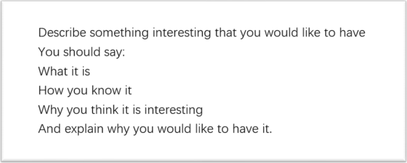

This reminds me of a cake. It’s a very special and interesting cake made by my best friend,

and I always wanted to have one myself.

I think it was my 19th birthday. My best friend was being mysterious all day. She told me she

had a big surprise for me. We met at a nice little restaurant as planned. She carefully placed

a beautiful cake on the table. It was a handmade mousse cake, my favorite flavor! She told

me, she spent the whole day making it. I felt so excited, so happy, so, how to say, exhilarated

to receive such a present.

I want to have such a DIY cake, and I want to make it myself. I am not a professional chef. But

this is a unique cake. One of a kind! Think about it, I need to search for the recipe, collect all

the ingredients, and all the mixing and stirring! After all, I could just buy one, right? But I won’t.

That will make the cake so special and so precious, and the process of making it will also be

so interesting.

And it will be more than interesting. When you think about friendship, or any other interpersonal relationships, it is always about loving and caring for each other. I mean, no one is an island. Sending a handmade gift is the best way to say: we are bonding. When someone receives something so kind, so personal, so genuine, they will be touched. This is why I want to receive interesting DIY objects, or to make one by myself and give it to the people I like.

**主题词汇和亮眼表达：**

**object：物品**

**10.让你情绪激动的电影**

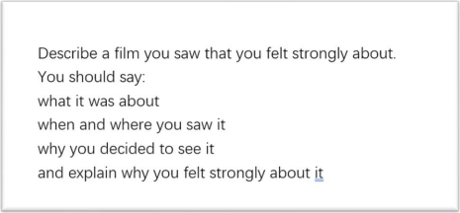

Last year, I watched a short film on the Internet. I felt bored that night and decided to watch

it. But it deeply touched me, and I felt strongly about it. It was about a couple who broke up

but promised to meet once a year; the film documents their meetings over ten years.

I still remember one of the meetings. It was the 9th meeting. The heroine was being

mysterious all day. She told the hero she had a big surprise for him. They met at a nice little

restaurant as planned. She carefully placed a beautiful cake on the table. It was a handmade

mousse cake, his favorite flavor! She told him, she spent the whole day making it. He felt so

excited, so happy, so, how to say, exhilarated to receive such a present.

At the end of that day, they talked a lot, from the cake to other stuff, it seemed that there

used to be a line, I mean, a boundary, between them, but because of the cake, the boundary

was gone. They became much closer, and that’s great.

And the most shocking part was: the heroine was an AI robot, an identical version of the

human being heroine! The human being heroine made it just to make sure the hero would

not be very lonely after she died.

The film was actually very short, and there was no fancy visual effect. But it raised my shock

and strong desire for love: it’s short, but romantic, and has a surprising plot twist.

**主题词汇和亮眼表达：**

**document：记录（作为动词）**

**identical version：完全一样的版本**

**heroine：女主角**

**hero：男主角**

**fancy visual effect：炫酷的视觉特效**

**plot twist：剧情反转**

**事**

**11.不寻常的假期**

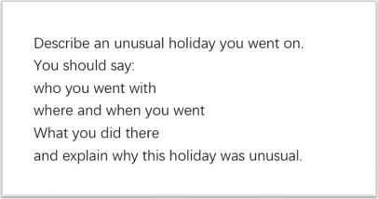

Well, I have always been very attached to a modern city like Chengdu. My grandparents live there and I went there last summer. I went there myself last summer. It is just so modern and fashionable, or you may say, it is cosmopolitan. It makes everything special, and you want to linger once you go there, especially because of the great food.

The holiday there was special because it was all about food. It is easier for me to feel the beauty of food when I am there. You can always feed your soul there. It’s not a cliché, I really feel so. I do. In Chengdu, you don’t need someone else to tell you dinner is ready. Instead, you get to see the various food and drinks along the streets. I mean, you can feel your saliva dropping. Everything can be so yummy, so delicious, and so palatable.

Last summer, when I was in Chengdu, I found something even more meaningful: the bonds between people, and that made my holiday more special. I mean, people living in other big cities are always so busy. They are always buzzing around, never willing to spare a second to say hi. You can feel the distance between people. They are separated by endless traffic jams, by all the tall, fancy but boring buildings. But we I was in Chengdu, things were totally different. The community there is small but close-knit. People know each other, care about each other, and sympathize each other. It’s good to know there is always a place for you.

**主题词汇和亮眼表达：**

**cosmopolitan：大都市的**

**linger： 常驻久留**

**feed your soul：喂养你的灵魂**

**saliva：唾液**

**palatable：玉盘珍馐式的**

**12.街上集市的购物经历**

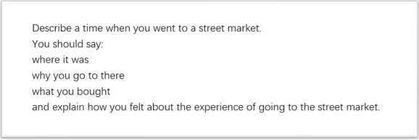

It reminds me of last summer when I went to Chengdu, a city full of street markets with great

food. Well, I have always been very attached to a modern city like Chengdu. My grandparents

live there and I went there last summer. It is just so modern and fashionable, or you may say,

it is cosmopolitan. It makes everything special, and you want to linger once you go there,

especially because of the street markets and great food.

There are so many street markets in Chengdu, they open at night and sell great food. It is

easier for me to feel the beauty of food when I am there. You can always feed your soul there.

It’s not a cliché, I really feel so. I do. In Chengdu, you don’t need someone else to tell you

dinner is ready. Instead, you get to see the various food and drinks along the streets. I mean,

you can feel your saliva dropping. Everything can be so yummy, so delicious, and so palatable.

Every time I would buy a lot of food and made my stomach very full.

Last summer, when I was in Chengdu, I found something even more meaningful: the bonds between people, especially in public places like street markets. I mean, people living in other big cities are always so busy. They are always buzzing around, never willing to spare a second to say hi. You can feel the distance between people. They are separated by endless traffic jams, by all the tall, fancy but boring buildings. But we I was in Chengdu, things were totally different. The street markets there are small but close-knit. The buyers and sellers know each other, care about each other, and sympathize each other. I think that’s the charm of the street markets in Chengdu: it’s not only about buying and selling, but also about bonding.

**主题词汇和亮眼表达：**

**cosmopolitan：大都市的**

**linger： 常驻久留**

**feed your soul：喂养你的灵魂**

**saliva：唾液**

**palatable：玉盘珍馐式的**

**13.喜欢的室外活动**

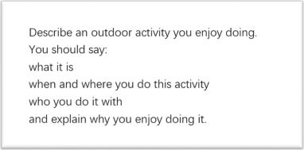

I enjoy eating outside, and I think that’s the most enjoyable outdoor activity I know. Especially

in cities with great food.

Well, I have always been very attached to a modern city like Chengdu. My grandparents live

there and I went there last summer. It is just so modern and fashionable, or you may say, it is

cosmopolitan. It makes everything special, and you want to linger once you go there,

especially because of the great food.

There are so many outdoor street markets in Chengdu, they open at night and sell great food.

It is easier for me to feel the beauty of food when I am there. You can always feed your soul

there. It’s not a cliché, I really feel so. I do. In Chengdu, you don’t need someone else to tell

you dinner is ready. Instead, you get to see the various food and drinks along the streets. I

mean, you can feel your saliva dropping. Everything can be so yummy, so delicious, and so

palatable. That’s the unique advantage of eating outside, compared to other outdoor

activities.

When you are out, eating in Chengdu, it seems that you are not on the outside, you will feel at home. Last summer, when I was in Chengdu, eating outside, I found something even more

meaningful: the bonds between people, I mean, people living in other big cities are always so

busy. They are always buzzing around, never willing to spare a second to say hi. You can feel

the distance between people. They are separated by endless traffic jams, by all the tall, fancy

but boring buildings. But we I was in Chengdu, things were totally different. The community

there is small but close -knit. People know each other, care about each other, and sympathize

each other.

**主题词汇和亮眼表达：**

**cosmopolitan：大都市的**

**linger： 常驻久留**

**feed your soul：喂养你的灵魂**

**saliva：唾液**

**palatable：玉盘珍馐式的**

**14.小学喜欢的活动**

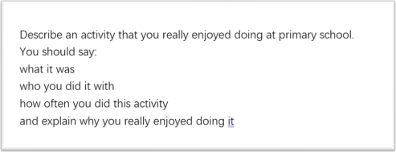

I have to say: it’s eating outside. I have always been a foodie and as a child, I enjoyed trying

all the good food in my hometown: Chengdu.

When I was little, my father would take me to the food markets every weekend and it was a special activity for me: special and delicious. It is easier for me to feel the beauty of food when I am at the food markets. You can always feed your soul there. It’s not a cliché, I really feel so. I do. In Chengdu, you don’t need someone else to tell you dinner is ready. Instead, you get to see the various food and drinks along the streets. I mean, you can feel your saliva dropping. Everything can be so yummy, so delicious, and so palatable.

（这一段的时态怎么又有【一般过去时态】， 又有【一般现在时态】？ ）

I loved to eat outside not only because of the food. When I began to know about interpersonal relationships, I found something even more meaningful: the bonds between people, I mean, people living in other big cities are always so busy. They are always buzzing around, never willing to spare a second to say hi. You can feel the distance between people. They are separated by endless traffic jams, by all the tall, fancy but boring buildings. But we I was in Chengdu, especially when I was eating outside, with my father, and maybe some strangers, things were totally different. The community there is small but close -knit. People know each other, care about each other, and sympathize each other.

**主题词汇和亮眼表达：**

**foodie：吃货**

**cosmopolitan：大都市的**

**linger： 常驻久留**

**feed your soul：喂养你的灵魂**

**saliva：唾液**

**palatable：玉盘珍馐式的**

**15.帮助他人**

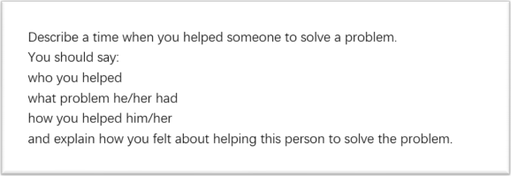

This reminds me of the time when I helped a child. I tutored a 10-year -old child English. But

we were in different cities, so I mainly taught him online and made some videos for him

sometimes.

The first video I made for him, I still remember, was about how to memorize difficult

vocabulary in English. It was just 10 words,but he told me it was so interesting, so intriguing,

and it captivated him at once.

Since then, I began to share more videos about my studying experiences, studying methods,

and even life lessons, sometimes. I have made, let me see, over 20 videos for him. The most

impressive video--can I say my video is impressive?-- was how I managed to remember 1000

words in three days. I mean, for a child, come on, that’s more than difficult, it’s very difficult,

it’s a daunting task. But, he did it! He divided these words into different groups, and he

adopted various ways to memorize them, and he even took advantage of different locations

to consolidate the memories. When he nailed those words, I was surprised to see this, no, I

was more than surprised, I was stunned.

This is how I helped him, or can I say, how I imparted my wisdom? I guess he liked me not

only because of the methods I shared, but also because deep deep down, we resonate with

each other, that’s very important for our communication.

**主题词汇和亮眼表达：**

**tutor：（动词）辅导**

**nail：搞定**

**impart wisdom：传授智慧**

**16.工作学习的好习惯**

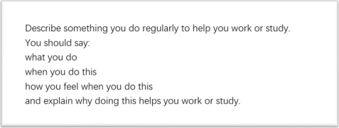

Recently, I have been studying the IELTS. And what I did to help my studying is to follow an

influencer. I’ll explain.

This influencer’s name is CongMingXueZhang, which can be loosely translated as Mr. Smart.

He is an influencer on DouYin, the Chinese version of TikTok. He creates videos about his

studying methods and experience. I still remember his first video: that was about how to

memorize difficult vocabulary in English. It was so interesting, so intriguing, and it captivated

me at once, and I started following him since then, and also since then, my foreign language

studying began to take off.

Basically, he shares videos about his studying experiences, studying methods, and even life

lessons, sometimes. From his video, you can totally tell that he is so smart, it’s like everything

in studying is just a piece of cake to him, he is almost, how to put it, omniscient, I guess. So

what I did was just follow his lead, and keep practicing, and I could pick up some really good

skills. The most impressive skill I learned from him was how he managed to remember 1000

words in three days. I mean, come on, that’s more than difficult, it’s very difficult, it’s a

daunting task. But, he did it! And I did it! He taught me how to divide these words into

different groups, and how to adopt various ways to memorize them, and even how to take

advantage of different locations to consolidate the memories. I was surprised to learn this, no,

I was more than surprised, I was stunned.

Learning from others is very efficient for us to improve our work or study. This is him, a

superman in the academic field. I guess he helped me to improve not only because he is

smart, but also because deep deep down, he resonates with me, I want to become smart,

become brilliant, and become omniscient as well.

**主题词汇和亮眼表达：**

**take off：某件事情成功**

**follow one’s lead：跟着某人（有样学样）**

**pick up：学会**

**17.少年时候学得很开心的技能**

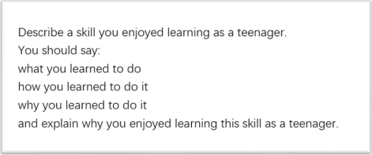

Since childhood, I have been studying English. And a very good skill I have been using to help

my studying is to follow an influencer. I’ll explain.

This influencer’s name is CongMingXueZhang, which can be loosely translated as Mr. Smart.

He is an influencer on DouYin, the Chinese version of TikTok. He creates videos about his

studying skills and experience. I still remember his first video: that was about how to memorize

difficult vocabulary in English. It was so interesting, so intriguing, and it captivated me at once,

and I started following him since then, and also since then, my foreign language studying

began to take off.

Basically, he shares videos about his studying experiences, studying skills, and even life lessons,

sometimes. From his video, you can totally tell that he is so skillful, it’s like everything in

studying is just a piece of cake to him, he is almost, how to put it, omniscient, I guess. So what

I did was just follow his lead, and keep practicing, and I could pick up some really good skills.

The most impressive skill I learned from him was how he managed to remember 1000 words

in three days. I mean, come on, that’s more than difficult, it’s very difficult, it’s a daunting task.

But, he did it! And I did it! He taught me how to divide these words into different groups, and

how to adopt various ways to memorize them, and even how to take advantage of different

locations to consolidate the memories. I was surprised to learn this, no, I was more than

surprised, I was stunned.

Learning from others is a very efficient skill for us to improve our work or study. This is him, a

superman in the academic field. I guess he helped me to improve not only because he is

smart, but also because deep deep down, he resonates with me, I want to become smart,

become brilliant, and become omniscient as well.

**主题词汇和亮眼表达：**

**take off：某件事情成功**

**follow one’s lead：跟着某人（有样学样）**

**pick up：学会**

**18.长久的目标**

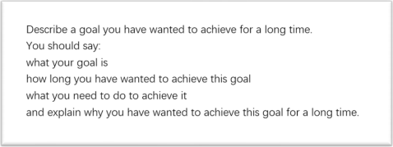

Actually, I have a lot of goals I haven’t achieved and wanted to achieve, but the last one was

the most frustrating.

My goal was to study English well and this has been my ambition like forever. But I constantly

tried and constantly gave up. However, last year I saw an influencer’s video and it rekindled

my passion.

His name is CongMingXueZhang, which can be loosely translated as Mr. Smart. He is an

influencer on DouYin, the Chinese version of TikTok. He creates videos about his studying

methods and experience.

Basically, he shares videos about his studying experiences, studying methods, and even life

lessons, sometimes. From his video, you can totally tell that he is so smart, it’s like everything

in studying is just a piece of cake to him, he is almost, how to put it, omniscient, I guess. I

wanted to become someone like him! So I followed one of his most impressive videos: that

was how he managed to remember 1000 words in three days. I mean, come on, that’s more

than difficult, it’s very difficult, it’s a daunting task. But, he did it! He shared how he divided

these words into different groups, and how he adopted various ways to memorize them, and

even how he took advantage of different locations to consolidate the memories. I was

surprised to see this, no, I was more than surprised, I was stunned.

All of those sound amazing. I decided to try. But, on the second day, my professor gave me a lot of work to do, and it took me a week to finish it. After that, it seems I forgot the English

studying thing, or not. But anyway, I haven’t finished my three -day project, and it was a

bummer.

**主题词汇和亮眼表达：**

**frustrating：令人沮丧的**

**ambition：雄心壮志**

**constantly：持续地**

**rekindled：重燃**

**bummer：令人失望的事物**

**19.忙碌的时刻**

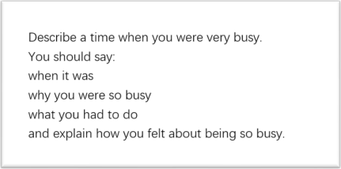

This reminds me of last month when I challenged myself to memorize 1000 English words in

three days. I was totally crazed. This is a long story, and it began when I started to follow an

influencer.

His name is CongMingXueZhang, which can be loosely translated as Mr. Smart. He is an

influencer on DouYin, the Chinese version of TikTok. He creates videos about his studying

methods and experience.

I followed him because I wanted to improve my English. Basically, he shares videos about his studying experiences, studying methods, and even life lessons, sometimes. From his video, you can totally tell that he is so smart, it’s like everything in studying is just a piece of cake to him, he is almost, how to put it, omniscient, I guess. And, he seems very busy. And I adore

that. I mean, I want to become busy too, busy, happy, and efficient.

I thus challenged myself to remember 1000 words in three days. I mean, come on, that’s more

than difficult, it’s very difficult, it’s a daunting task. But, he did it! And I would like to try! That

was three busy days, I mean, it was more than busy, it was like torture. I divided these words

into different groups, and adopted various ways to memorize them, and even took advantage

of different locations to consolidate the memories.

In the three days, it was about words, words, and words. I was like memorizing words in the

classroom, memorizing words when I was eating, and even memorizing words when I was in

the restroom. At last, I nailed it. I spent the busiest, and the most productive three days. It was

totally worth it.

**主题词汇和亮眼表达：**

**challenge oneself to do sth：挑战自我去做某事**

**crazed：形容忙到发疯（也可以用 crazy，是很口语的说法）**

**adore：崇拜、非常喜欢**

**torture：折磨**

**sb was like doing sth：这里的 like 不是“喜欢”， 而是很口语的说法，表示回忆过去所作的 事情， 如果真要翻译，可以翻译成“好像”**

**nail：搞定**

**productive：充实的**

**20.急需速度的一件事**

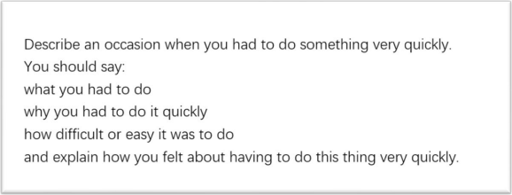

This reminds me of last month, when I challenged myself to memorize 1000 English words in

three days. I was totally crazed. This is a long story, and it began when I started to follow an

influencer.

His name is CongMingXueZhang, which can be loosely translated as Mr. Smart. He is an

influencer on DouYin, the Chinese version of TikTok. He creates videos about his studying

methods and experience.

I followed him because I wanted to improve my English, and as quickly as possible. Basically,

he shares videos about his studying experiences, studying methods, and even life lessons,

sometimes. And, he seems very efficient. And I adore that. I mean, I want to become efficient

too, to conquer my English studying as soon as possible.

I thus challenged myself to remember 1000 words in three days. I mean, come on, that’s more than difficult, it’s very difficult, it’s a daunting task. Both speed and accuracy were required! But, he did it! And I would like to try! That was three busy days, I mean, it was more than busy, it was like torture. I divided these words into different groups, and adopted various ways to memorize them, and even took advantage of different locations to consolidate the memories.

The three days passed quickly, and it was about words, words, and words. I was like memorizing words in the classroom, memorizing words when I was eating, and even memorizing words when I was in the restroom. At last, I nailed it. The speed I had in those three days was really impressive. I had never memorized English words so quickly.

**主题词汇和亮眼表达：**

**challenge oneself to do sth：挑战自我去做某事**

**crazed：形容忙到发疯（也可以用 crazy，是很口语的说法）**

**adore：崇拜、非常喜欢**

**torture：折磨**

**sb was like doing sth：这里的 like 不是“喜欢”， 而是很口语的说法，表示回忆过去所作的 事情， 如果真要翻译，可以翻译成“好像”**

**nail：搞定**

**21.不想做的工作**

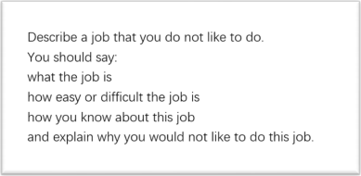

Actually, I am ok with most jobs I need to do at my school, but there is one I don’t like. It’s set

by my English teacher. She tells us to study English hard, which I am totally ok with; but she

also tells us to follow an influencer on Douyin, the Chinese version of TikTok, to totally copy

his studying methods, I don’t like it.

如果是上班族， 可以做如下修改：

Actually, I am ok with most jobs I need to do at my work, but there is one I don’t like. It’s set

by my boss. English is necessary for our work, and my boss tells us to study English hard,

which I am totally ok with; but she also tells us to follow an influencer on Douyin, the Chinese

version of TikTok, to totally copy his studying methods, I don’t like it.

The influencer’s name is CongMingXueZhang, which can be loosely translated as Mr. Smart.

He creates videos about his studying methods and experience.

The first video my English teacher asked us to watch, I still remember, was about how to memorize difficult vocabulary in English. My English teacher thought it was so interesting, so intriguing, and it captivated her at once, and she asked us to follow him since then.

And last month, my English teacher told us to follow one of his most popular videos: it was how he managed to remember 1000 words in three days. I mean, come on, that’s more than difficult, it’s very difficult, it’s a daunting task. But, he did it! He shared how he divided these words into different groups, and how he adopted various ways to memorize them, and even how he took advantage of different locations to consolidate the memories. I admit I was surprised to see this, no, I was more than surprised, I was stunned. But, the problem is, I didn’t have the time! And, what he memorized was GRE vocabulary, and I don’t need it!

So, I don’t see the point of this job. To follow someone excellent, that sounds great; but it’s not feasible sometimes, I think we should just consider our own situation as well.

**主题词汇和亮眼表达：**

**be ok with：能接受**

**set rules：作出规定**

**copy：照抄； 照搬**

**the point of sth：某件事的意义**

**feasible：可行的**

**22.有用的地图**

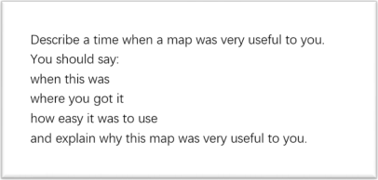

Actually, I don’t use maps a lot since I have a good sense of direction. I just had to use the

map once in the countryside.

Well, I have always been very attached to the countryside. My grandparents live there and I went there last summer. It is just so peaceful and quiet, or you may say, it is tranquil. It slows everything down, and blocks out all the hustle and bustle of the city.

But since I was not familiar with the paths in the countryside, it was easy to get lost. One day

in last summer, when the dusk came, I got lost, and my phone died as well so I couldn’t turn

use the online map.

Then, a villager found me and led me to my grandparents ’ house. After we arrived, he even

drew a little map for me in case I got lost again. The drawing was very simple, even naïve, but

I found something more meaningful from it: the bonds between people. I mean, people living

in the city are always so busy. They are always buzzing around, never willing to spare a second

to say hi. But when I was in the countryside, things were totally different. The community there

is small but close -knit. People know each other, care about each other, and sympathize with

each other.

I actually used the map just once after that day, but I think it not only gives me the right

direction in the countryside, but also leads my heart back home.

**主题词汇和亮眼表达：**

**sense of direction：方向感**

**dusk: 黄昏**

**die： （手机） 没电关机了**

**23.听到有人抱怨**

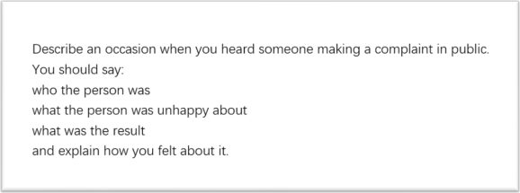

This reminds me of my 19th birthday. Something went wrong with the cake shop, and my

girlfriend made a huge complaint about it.

She bought a cake -DIY project at the shop and was able to make a cake by herself. She thought this idea was brilliant and would surprise me. She was not a professional chef. But

this is a unique present. One of a kind! Think about it, she had to search for the recipe, collect

all the ingredients, and all the mixing and stirring! After all, she could just buy one, right? But

she did not. That made the cake so special and so precious.

At last, she made it. The cake was not gorgeous, but it meant a lot. Sending a handmade gift

is the best way to say: we are bonding. When someone receives something so kind, so

personal, so genuine, they will be touched.

But the problem came up. My girlfriend and I met at a nice little restaurant as planned, and

waited for the cake to be delivered to us. However, the delivery man was one hour late, and

what’s worse, he fell on the way and the cake got smashed. When we finally opened the box,

the cake was like a melted ice-cream…

My girlfriend made a phone call to the cake shop and complained about it. At last, we got a refund from the cake shop. But we would rather have a complete cake than the refund.

**主题词汇和亮眼表达：**

**gorgeous：极其美丽的**

**come up：发生**

**deliver：配送**

**smashed：碎成渣渣的**

**melted：融化的**

**refund：退款**

**24.捡到失物**

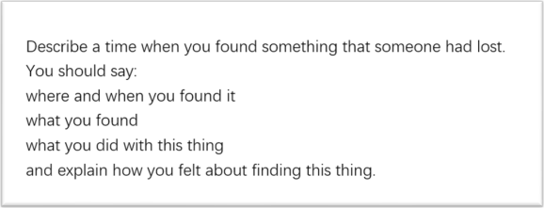

This reminds me of my 19th birthday. It should be romantic and perfect, but my girlfriend lost

her purse, and the whole event was ruined.

I remember vividly that my girlfriend was being mysterious all day. She told me she had a big

surprise for me. We met at a nice little restaurant as planned. She carefully placed a beautiful

cake on the table. It was a handmade mousse cake, my favorite flavor! She told me, she spent

the whole day making it. I felt so excited, so happy, so, how to say, exhilarated to receive such

a present.

And the next stage was just romantic, I still remember we talked a lot, from the cake to other stuff, it seems that there used to be a line, I mean, a boundary, between us, but because of the cake, the boundary was gone. We became much closer, and that’s great.

And, I had the feeling that something would come up, and it did. She couldn’t find her purse. She insisted that she would pay for the dinner, so if her wallet was gone for good/lost, then I need to pay; I was totally ok with that, but that was a big no in her world.

At last, all the waiters helped us to look for her purse, but still no luck. And, finally, I found it

in the box of the cake, covered by the birthday-card. Everyone felt relieved, and she paid for

the dinner.

**主题词汇和亮眼表达：**

**remember vividly：清楚地记得**

**the next stage：下一个阶段**

**something would come up：有事会发生**

**be gone for good：永远消失（是一个很口语的说法）**

**a big no ：坚决不**

**in one’s world：在 XX 的价值观里**

**no luck：没成功（是一个很口语的说法）**

**relieved：松了一口气的**

**25.嘈杂的时刻**

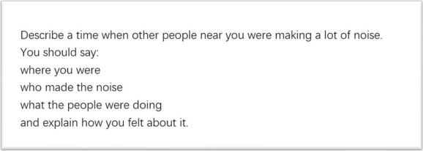

This reminds me of my 19th birthday. It should be romantic and perfect, but some people were

having a fight and making a lot of noise, and the whole event was ruined.

I remember vividly that my girlfriend was being mysterious all day. She told me she had a big

surprise for me. We met at a nice little restaurant as planned. She carefully placed a beautiful

cake on the table. It was a handmade mousse cake, my favorite flavor! She told me, she spent

the whole day making it. I felt so excited, so happy, so, how to say, exhilarated to receive such

a present.

And the next stage was just romantic and quiet, I still remember we talked a lot, from the cake

to other stuff, it seems that there used to be a line, I mean, a boundary, between us, but

because of the cake, the boundary was gone. We became much closer, and that’s great.

And, I had the feeling that something would come up, and it did. The couple next to our table

started to yellat each other out of blue. The woman was crying, and the man was screaming.

It was really loud, and all the other customers were looking at them; the scene was very ugly.

At last, all the waiters helped to ease the couples’ anger and the fight was finally over. They

went back to their dinner, and we did, too. However, the air was still tense and weird.

**主题词汇和亮眼表达：**

**have a fight：吵架/打架**

**remember vividly：清楚地记得**

**the next stage：下一个阶段**

**something would come up：有事会发生**

**do sth. out of blue：没来由地突然 XX**

**the scene was very ugly：场面很难看**

**ease one’s anger：平息 XX 的怒火**

**tense： （氛围） 紧张的**

**weird：奇怪的**

**26.被推迟的旅程**

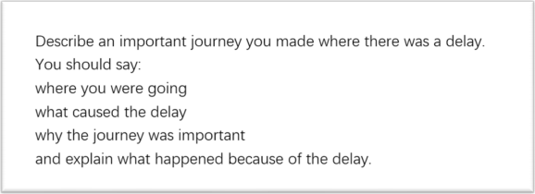

This reminds me of my 19th birthday. I was leaving that evening for a journey to Japan, but

my friend insisted that we should meet before that. I felt reluctant because the journey was

important for me: I wanted to go visit Japan since long long ago.

My best friend was being mysterious all day. She told me she had a big surprise for me. We

made an appointment to meet at a nice little restaurant.

However, I was really busy during the day and totally forgot the appointment. And 30 minutes after the meeting time, I got a call from her. She totally flipped out/got angry and asked where

I was. Then I grabbed a taxi and rushed to the restaurant.

On my way there, she kept nagging on the phone. She said she made a cake for me. And

since she was not a professional chef, she had to search for the recipe, collect all the

ingredients, and all the mixing and stirring. After all, she could just buy one, right? But she did

not. That made the cake so special and so precious.

I appreciated her kindness in making the cake, but I was afraid I was going to be late for my trip. However, I still met her at the restaurant. she carefully placed a beautiful cake on the table. It was a handmade mousse cake, my favorite flavor! She told me, she spent the whole day making it. I felt so excited, so happy, so, how to say, exhilarated to receive such a present.

And, maybe I got too drunk in the happiness and I forgot to leave for the airport. When I found out, I only had one hour left. At last, I had to postpone my trip and rebook my flight.

**主题词汇和亮眼表达：**

**reluctant：不太情愿的**

**grab：抓**

**rush to somewhere：冲向某处**

**flip out：生气**

**nag：抱怨**

**get too drunk in sth：沉浸在 XX 里**

**postpone：推迟**

**rebook：改签**